ansible task 03

Write a single ansible playbook which will install apache and nginx. Note: Playbook should not be hardcoded and pass the variables from different file.
# vi web_servers.yml
---
- name: Install web server using external variables
hosts: all
become: yes
vars_files:
- vars/web_vars.yml
tasks:
- name: Install selected web server
package:
name: "{{ web_package }}"
state: present
- name: Start and enable service
service:
name: "{{ web_service }}"
state: started
enabled: yes
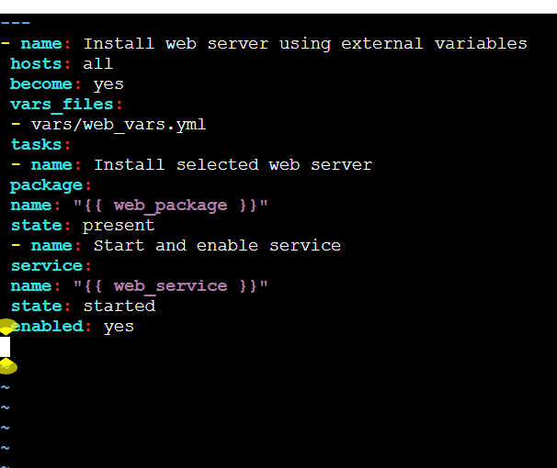
# create the one directory -- > mkdir vars
# cd vars/
# vi web_varr.yml
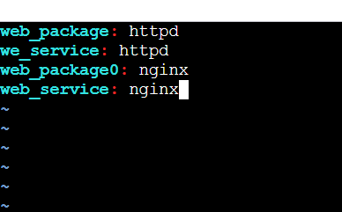
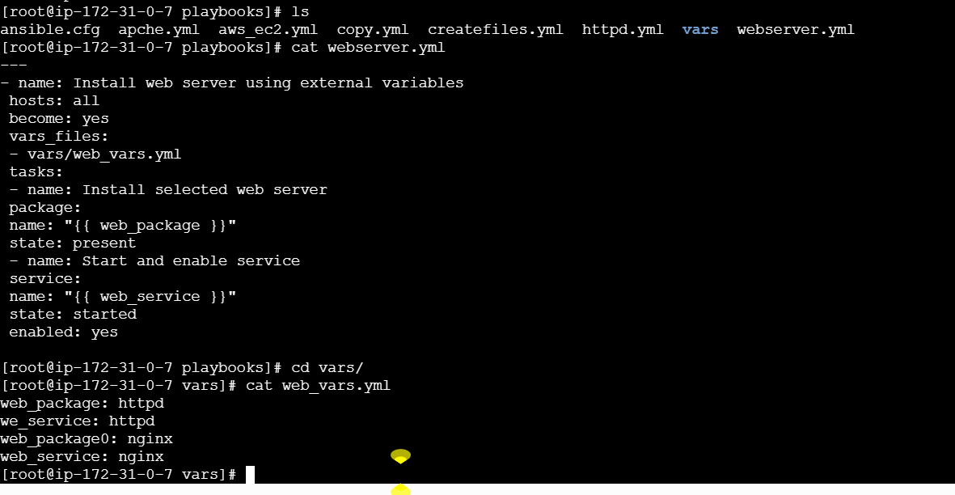
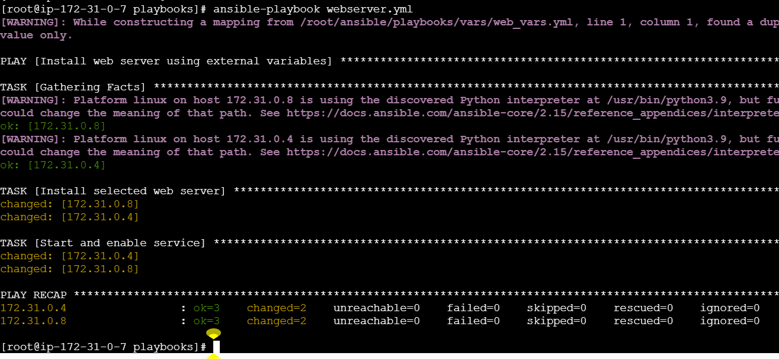

Ansible playbook to create 10 different directories with minimal code and directory names should be passed as variables.
# ✅ **Playbook: create_dirs.yml**
```yaml
---
---
- name: Create multiple directories
hosts: all
become: yes

vars:
dir_list:
- dir1
- dir2
- dir3
- dir4
- dir5
- dir6
- dir7
- dir8
- dir9
- dir10

tasks:
- name: Create directories
file:
path: "/tmp/{{ item }}"
state: directory
loop: "{{ dir_list }}"
---
# ✅ How it works (simple explanation)

* `dir_list` contains **10 directory names**
* The task loops through each name
* Creates the directory under `/tmp/dir1`, `/tmp/dir2`, … `/tmp/dir10`

---

# ✅ Run it

```bash
ansible-playbook create_dirs.yml
```
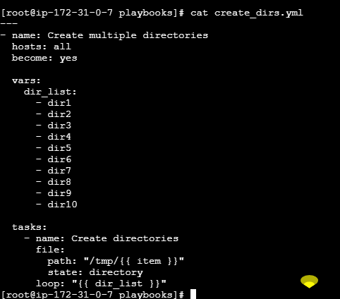

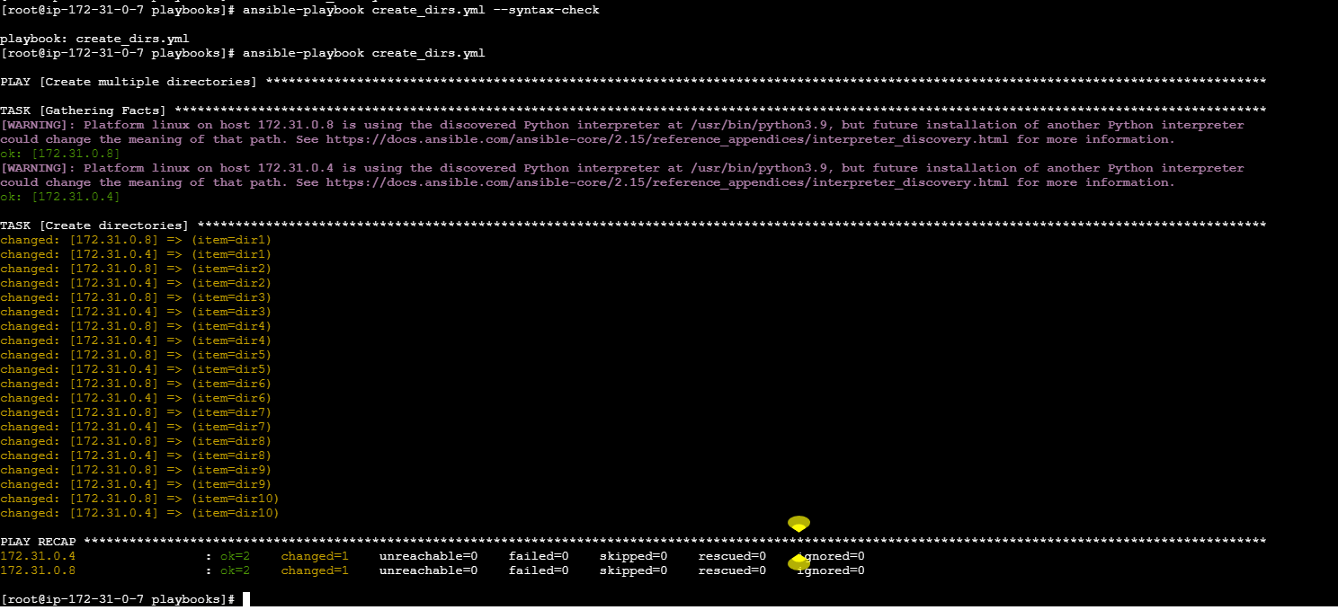

Ansible playbook to copy ssh-keygen from master to worker nodes. Note: a)Provision new 3 ec2 machines, one master and two worker nodes. b)Create common user called ansadm and provide sudo priviliges on 3 ec2 instances. c)Create ssh-keygen in master and your playbook should copy the keygen making it password less authentication.
# copy the pem key to the ansible master and give the permission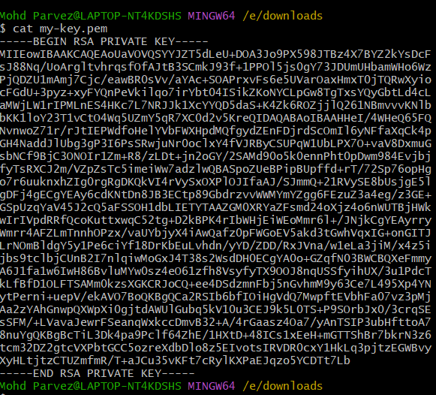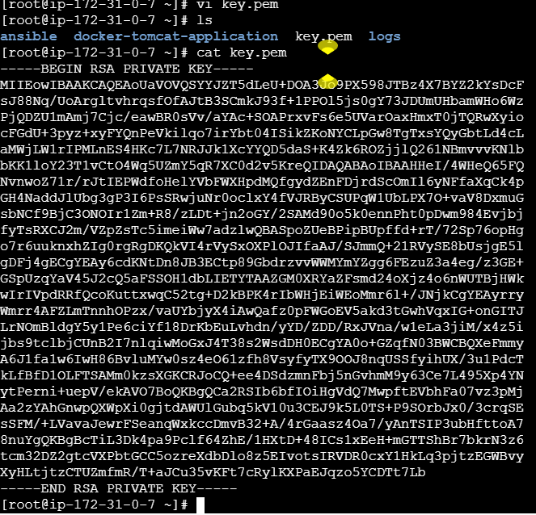

# ✅ **PLAYBOOK: setup_ssh_key.yml**

This playbook does:

1. Creates user **ansadm** on all machines
2. Gives **sudo privileges**
3. Generates SSH key on master (if not already generated)
4. Copies public key to worker nodes = **passwordless login**

---

---
# 1. Create user and sudo access on all nodes
- name: Create ansadm user on all nodes
hosts: all
become: yes

tasks:
- name: Create user ansadm
user:
name: ansadm
state: present
shell: /bin/bash
create_home: yes

- name: Allow ansadm passwordless sudo
copy:
dest: /etc/sudoers.d/ansadm
content: "ansadm ALL=(ALL) NOPASSWD: ALL"
mode: '0440'

# 2. Generate SSH key on the master
- name: Generate SSH key on master only
hosts: master
become: yes
become_user: ansadm

tasks:
- name: Create .ssh directory
file:
path: /home/ansadm/.ssh
state: directory
mode: '0700'

- name: Generate SSH key
openssh_keypair:
path: /home/ansadm/.ssh/id_rsa
type: rsa
owner: ansadm
group: ansadm
mode: '0600'
state: present

# 3. Copy SSH key to worker nodes
- name: Copy SSH key to workers
hosts: workers
become: yes

tasks:
- name: Copy master's id_rsa.pub to worker authorized_keys
authorized_key:
user: ansadm
key: "{{ lookup('file', '/home/ansadm/.ssh/id_rsa.pub') }}"
state: present
---
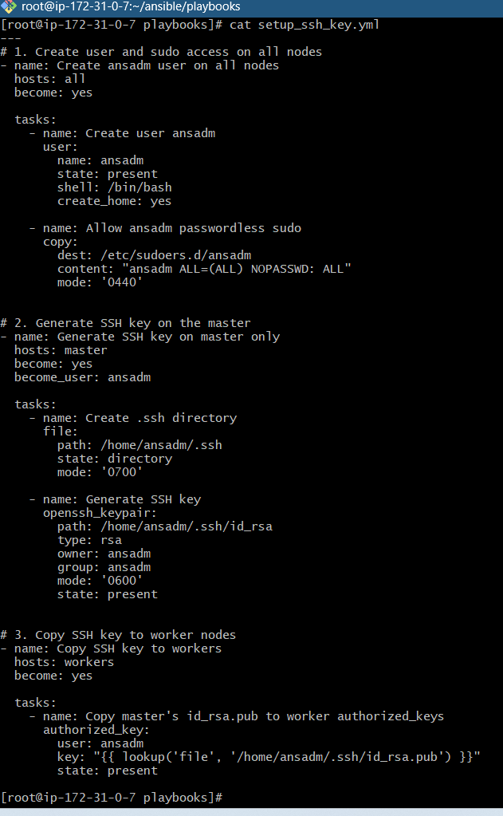
# ✅ **You must define inventory groups**
Create `hosts.ini`:
---
[master]
master-node ansible_host=172.31.0.7 ansible_user=ec2-user ansible_ssh_private_key_file=/root/key.pem

[workers]
worker01 ansible_host=172.31.0.4 ansible_user=ec2-user ansible_ssh_private_key_file=/root/key.pem
worker02 ansible_host=172.31.0.8 ansible_user=ec2-user ansible_ssh_private_key_file=/root/key.pem---
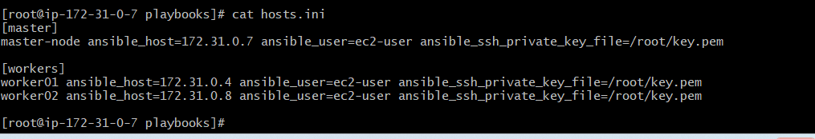
# ✅ **Run the playbook**

```bash
ansible-playbook -i hosts.ini setup_ssh_key.yml
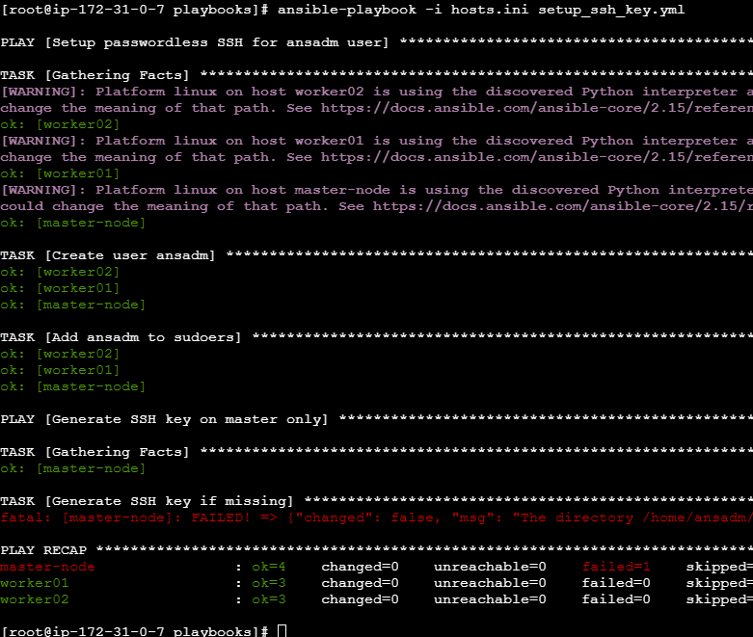

---

# ✔ What this accomplishes

After running it:

* User **ansadm** exists on all 3 EC2 machines
* **sudo access** is configured
* SSH key created on **master**
* Key copied to **workers**
* Now the master can SSH into workers without a password:

```bash
ssh ansadm@worker1
ssh ansadm@worker2
or
sudo -u ansadm ssh 172.31.0.4 # worker01
sudo -u ansadm ssh 172.31.0.8 # worker02
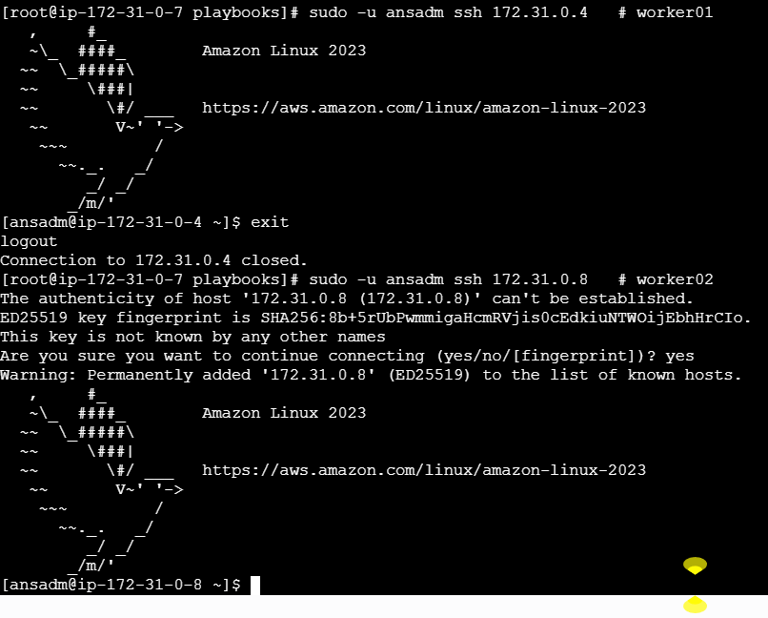

Ansible playbook to inject ansible vault variables.

**STEP 1 — Create a vault file**
Run:

#bash
ansible-vault create secret_vars.yml

It will ask for a password → set any vault password you want.
Then the file opens in an editor. Add variables like:

yaml
db_user: admin
db_password: MySecretPass123
api_key: ABCD-1234-XYZ

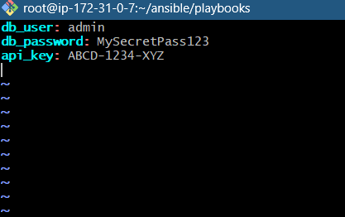
Save & exit.
Now the file is **encrypted**.
---
**STEP 2 — Use vault variables in a playbook**
Create: `vault_playbook.yml`
yaml
---
- name: Inject Ansible Vault variables example
hosts: all
become: yes

vars_files:
- secret_vars.yml

tasks:

- name: Show the vault variables (debug only)
debug:
msg: "DB User = {{ db_user }}, Password = {{ db_password }}, API Key = {{ api_key }}"
```

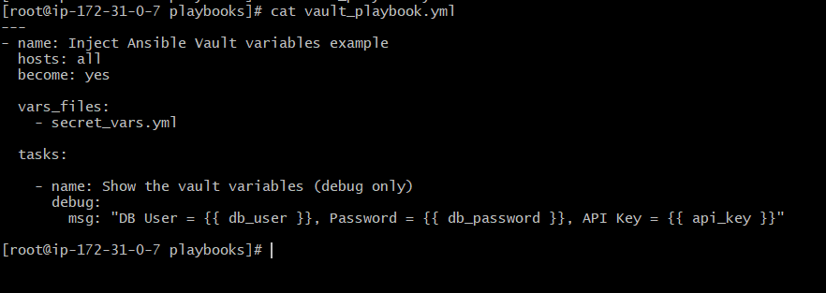

# ⚠ IMPORTANT

If your vault file is encrypted, Ansible will ask for a vault password while running the playbook.

---

**STEP 3 — Run the playbook**

Run:

#bash
ansible-playbook vault_playbook.yml --ask-vault-pass

OR if using vault password file:
#bash
ansible-playbook vault_playbook.yml --vault-password-file vault.pass
---

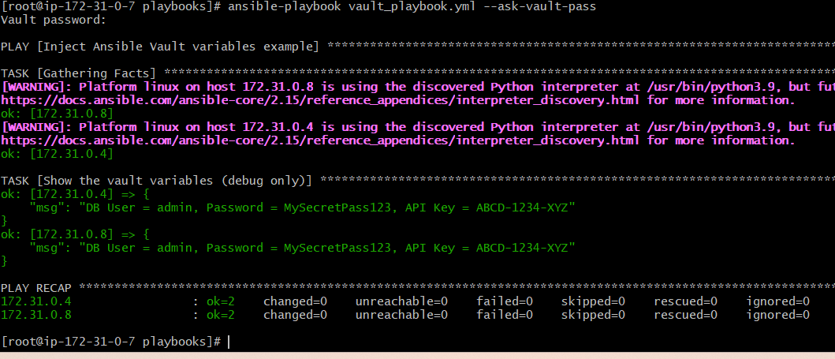
# 🛡 Best Practices

✔ Never store plain passwords
✔ Store all sensitive data in vaulted files
✔ Use `vars_files` to load vault variables
✔ Use `--ask-vault-pass` or `--vault-password-file` when running playbooks

